# Simulink: Batch-fed Penicillin Fermentation Process:

* Initial variables set based on ranges from literature
* PRBS added to inputs to simulate noise in signals
* Varying initial conditions + a threshold range means that the switch from batch->fedbatch (~Substrate=0.3g/L) occurs at different times, and batches are out of alignment
* End of batch is triggered by a quality metric (Penicillin >= 1.3 g/L), max simulation time at 450h (diminishing penicillin production thereafter)

# Validation of Simulation vs. Literature

# Generate Historical Data

# Generate Golden ‘Reference’ Trajectory

Two Strategies:

1. Simulation output with all variables maintained in optimal ranges
2. ‘mined’ from historical data as a cleaned average of all runs

This achieves the cut-off Penicillin production P=1.3 g/L in ~300hours but its run for 450h as the max batch period, achieving ~P=1.5 g/L by the end

# Alignment of Trajectories using DTW

‘**Vanilla’ DTW – No Warping Window vs. Specified Warping Window**

Option 1 – from historical data

Switching from batch->fedbatch substrate is fed to the system

Substrate flowrate ideal indicator variable…infer min/max warping range from historical batches

Loss of generality

Answer: Warping window ~20-30 hours

Option 2 – find a global optimal warping window

1:1 warping window -> linear Euclidean mapping

Inf:1 warping window -> ‘unconstrained’ non-linear DTW mapping

Define optimal warping window based on diminishing returns

# Global Alignment

Requirements:

Simultaneous warping OR constrained warping path length

Open start/end

Batch 1 vs. Reference

Batch 2 vs. Reference

Batch 3 vs. Reference

# Generalization of DTW to multi-dimensional case

1. dependant, known as DTWd
2. independent, known as DTWi

# LDTW

Implementation in python

Asymmetric DTW algorithm – warps a sample signal vs. reference signal with a specified max. time domain

Does not support warping windows

# Step Patterns

# Next: Data Unfolding

Decompose three-way batch data (IxJxK) into two-way data

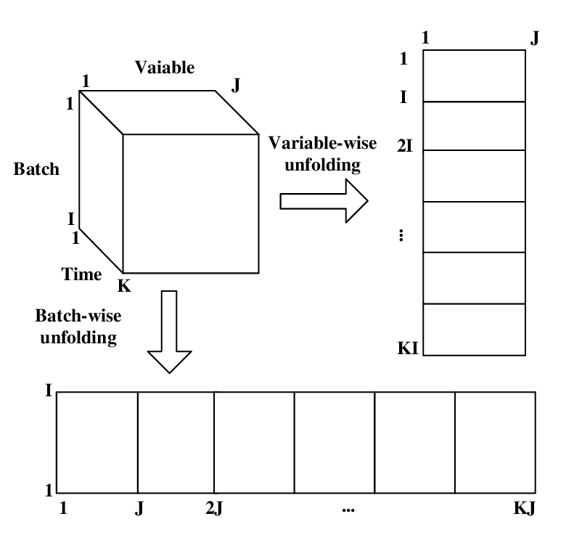

<normalize>

# Next: Clustering

Initialize with DBScan